The Four Stages of Child-Centred Play Therapy (CCPT)
Child-Centred Play Therapy helps children work through feelings, develop self-confidence, and find emotional balance. It follows a natural process of healing and growth, moving through four key stages.
Here’s what to expect:
Warm-Up Stage: Feeling Safe and Connected
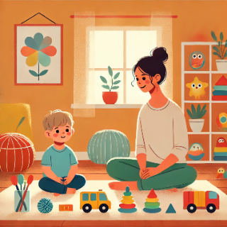 | - Your child and I build a trusting relationship.  - Your child explores the playroom, learns the boundaries, and starts to feel secure in this space.  - This stage lays the foundation for deeper emotional work.
Expressive Play Stage: The work starts
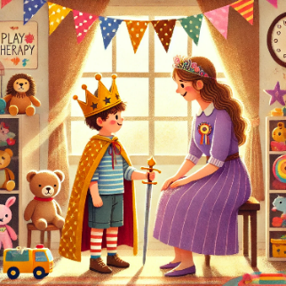 | - Your child may use play to work through what they find tricky and express their feelings.  - I will ensure your child feels safe as they release these strong feelings.
Nurturing Stage: Seeking Comfort and Care
 | - Once those big emotions are addressed, your child may show younger or more nurturing behaviours.  - Their play might focus on themes like protection and attachment.
Mastery Stage: Growing Confidence and Balance
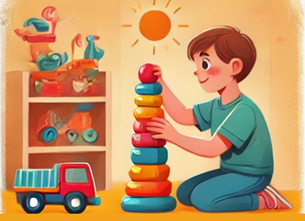 | - Your child shows signs of emotional growth with steady play.  - They may appear more confident, capable, and self-assured.  - This stage reflects emotional stability and readiness to move forward as therapy begins to wind down.
Each child moves through these stages at their own pace and can sometimes return to stages as needed.

