**Special Playtime- Cheat Sheet**

Child-Parent Relationship Therapy is a type of therapy that helps parents use play to connect with their children and support their emotional well-being. Parents learn simple play techniques to create a special environment full of playfulness and safety.

|  |
| --- |
| Setting up ‘Special Playtime’ at Home |
| Alarm clock with solid fillSet Aside a Regular Time Weekly: Dedicate consistent, uninterrupted periods for the ‘special playtime’ sessions, such as every Monday at 4 p.m. for 20-30 minutes.  Home outlineCreate a Safe Space: Ensure the play environment is free from distractions (e.g. no technology). Place yourself in the middle of the space and let your child move around you.  Stuffed Toy outlineToys: The toys don’t need to be fancy; they can be everyday items like saucepans, bubbles, paper/pencils, Lego, soft toys, etc.  Man with kid with solid fillFollow the Child's Lead: Allow your child to direct the play, observing and participating (when invited) without judgment or direction.  Confused face outline outlineEmpathetic Reflection: Comment on your child's actions and emotions during play to show understanding and validation.  i.e. “You’re excited to show me what you have made there.” “You’ve turned that pan around.” |
| Benefits of Special Playtime Therapy:   * *Enhanced Parent-Child Relationship:* Regular, focused playtime fosters trust and strengthens the emotional connection between parent and child. * *Improved Communication:* Children often express thoughts and feelings through play that they might not articulate verbally, providing parents with deeper insights. * *Behavioural Improvements:* As children feel more understood and secure, behavioural issues may decrease.   For a visual demonstration of "Special Playtime", watch the following video: [youtube.com/watch?v=i2GBoxA2JI8](https://www.youtube.com/watch?v=i2GBoxA2JI8) or look up Filial Play Therapy: "Special Playtime" in Child Parent Relationship Therapy (CPRT) By Dr Nick Cornett |

**Extra Help with Empathic Reflections**

**What is an Empathic Reflection?**

An empathic reflection is a way to show your child that you understand what they are feeling. Even if you haven’t had the same experience, you can reflect their emotions and help them feel supported. It’s like saying, “I see you, I hear you, and I understand how you feel.” You can use empathic reflection’s all the time with you child but especially in your Filial Therapy ‘Special’ Play Time.

**How Does It Help the Child?**

When adults respond to a child with empathy, it helps the child feel:

* Heard: They know someone understands them.
* Seen: Their emotions are noticed and respected.
* Safe: This builds trust with the adults around them, and they might share more.

**Examples of Empathic Reflections**

* *“You look a bit bored with this book. Let’s finish two more pages, then we’ll go for a walk.”*
* *“Oh that’s frustrating, it’s not quite working how you want it to.”*
* *“I see that big smile! You’re excited because it’s almost playtime!”*

By acknowledging their emotions first, you help the child feel understood. These responses can also help the child recognise and name their feelings, whilst helping build a memory log of what they can do/ask for next time they feel that way.

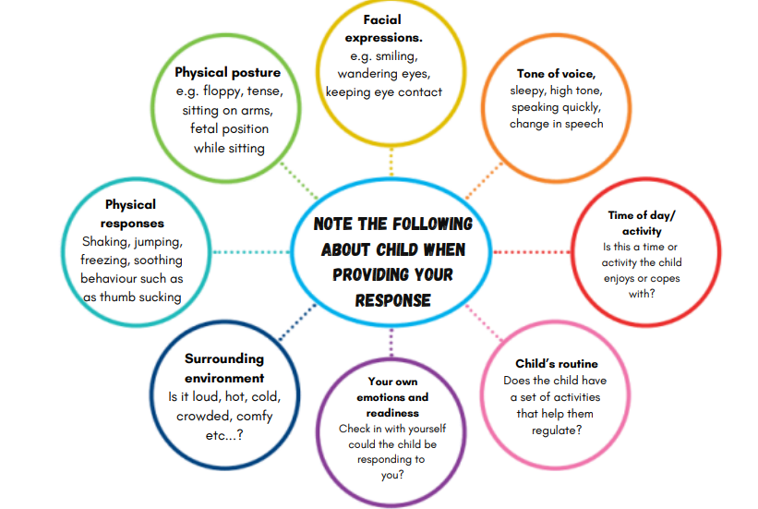

Think about these things to help you understand what the child might be ‘saying’